

**DEERWALK INSTITUTE OF TECHNOLOGY**

**AGRO BIZ**

SOFTWARE REQUIREMENT SPECIFICATION

**[SRS]**

Version 0.1

25th Oct 2017

Raju Shrestha

Prepared for

**Deerwalk Institute of Technology**

Instructor: Manish Man Singh

# Revision History

|  |  |  |
| --- | --- | --- |
| **Description** | **Author** | **Comments** |
| 0.1 | Raju Shrestha | Initial Specification |
|  |  |  |
|  |  |  |
|  |  |  |

# Document Approval

The following Software Requirements Specification has been accepted and approved by the following:

|  |  |  |
| --- | --- | --- |
| **Signature** | **Title** | **Date** |
|  |  |  |
|  |  |  |
|  |  |  |

Contents

Revision History 2

Document Approval 2

1. Introduction 1

1.1 Problem Definition 1

1.2 Objective 1

1.3 Purpose 2

1.4 Scope 2

1.5 Definitions, Acronyms and Abbreviations 2

1.6 Overview 3

2. General Description 3

2.1 Product Perspective 3

2.2 Product Functions 4

2.3 User Characteristics 4

2.4 General Constraints 5

2.5 Assumptions and Dependencies 5

3.1 External interface requirements 6

3.1.1 User Interfaces 6

3.1.2 Hardware Interfaces 10

3.1.3 Software Interfaces 10

3.3.4 Communications Interface 10

3.2 Functional Requirements 10

3.2.1 Create user credentials 10

3.2.2 Post Query, Sell/Advertise product 11

3.2.3 Agricultural product whole-sellers and retailers 11

3.2.4 Ask questions to Agricultural Exports 11

3.2.5 Agricultural exports to reply the queries 11

3.2.6 Agricultural exports post information 11

3.3.7 Agricultural product sellers 12

3.3.8 Customers can search for new product 12

3.3.9 Consumers can buy agricultural product 12

3.3 Use Cases 12

3.3.1 Create user Credentials 12

3.3.2 Post Query, Sell/Advertise product 13

3.3.3 Agricultural product whole-sellers and retailers 14

3.3.4 Agricultural product buyers/consumers 15

3.3.5 Agricultural Experts 16

3.4 Classes / Objects 17

3.4.1 Users 17

3.4.2 Agro product sellers 17

3.4.3 Agro Producers (Farmer) 18

3.5 Non-Functional Requirements 18

3.5.1 Performance 18

3.5.2 Reliability 18

3.5.3 Availability 18

3.5.4 Security 18

3.5.5 Maintainability 18

3.5.6 Portability 18

3.6 Design Constraints 19

3.7 Logical Database requirements 19

4. Analysis Models 19

4.1 Sequence Diagram 19

4.1.1 Sequence diagram for Admins 19

4.1.2 Sequence diagram for Agro Product Producer (Farmer) 20

4.1.3 Sequence diagram Agro product sellers (whole-sellers/retailers) 21

4.1.4 Sequence diagram for Agricultural exports 22

4.2 Data Flow Diagrams (DFD) 23

4.2.1 Context diagram 23

4.2.2 Diagram for queries request/response 24

4.2.3 Diagram for buying/selling product 25

4.3 State Diagrams 26

4.3.1 State diagram for admin 26

4.3.2 State diagram for Agro-Producers (Farmer) 27

4.3.3 State diagram for Agricultural Experts 28

4.3.4 State diagram for Agro-Product Sellers (whole-sellers/retailers) 29

4.3.5 State diagram for costumers/consumers 30

5. Change Management Process 30

A. Appendices 30

A.1 Business Requirement Document 30

## 1. Introduction

‘**Agro Biz’** is a mobile based application which provides complete guide to both agricultural product producers (farmers) and customers (whole-sellers, retailers and consumers).This application has four types of users; admin, producer (farmer), sales person and consumers.

Admin can update new features and add information about recent technology and methods used to produce high quality disease free product, market price and success history of farmers to motivate people in agricultural field. Agricultural product producers (farmer) can advertise their products according to admins post including product details (like product name, product rate, quantity) and available places. And the agricultural product sales-person (whole-seller and retailers), and consumers can post their needs along with product details and required place.

Thus, this app will provide a complete platform to connect with producers and costumers, buy and sell product, provide recent information along with requirement for doing commercial agriculture and animal farming, market situation in agricultural and animal product business and success history to motivate people in this field.

## Problem Definition

All human beings use agricultural or animal product to live alive in day-to-day life. Food is basic needs of all the living beings. We human beings consume foods like vegetables, grains, pulse, fruits, and animal products like milk, yoghurt, ghee, honey, eggs, meat, fish, and so on.

Locally available fresh fruits, green vegetables, grains, eggs and meat provide nutrients like vitamins, mineral, proteins, fat and carbohydrate. These nutrients are essential for the growth, development and proper functioning of human body.

Getting fresh local and organic products becomes difficult in places like in Kathmandu valley. If someone gets, it will be not fresh, original and chemical free. It takes up to 2/3 week to arrive from farm to market. The shopkeeper are not selling the original product, they mix other product like mixing of sugar in honey, vegetable ghee on animal ghee, water on milk, chemicals on fruits and so many others for their profit.

Farmers may not have clear idea about commercial production of agricultural product, recent technology developed and methods used to produce high quality product. Also, they do not get information about market price and demands. So, the purposed application can help in many ways with users ranging from farmers to customers.

## Objective

The major objective of this product is to provide information about scientific methods and techniques used to produce high quality disease free agricultural crops and animal product. This also provides information about protection and caring techniques, climatic and soil condition required and fertilizers used to product disease free agricultural and animal product.

This also provide information of buying and selling the product, provide the recent market situation like price, demand, success history of farmers and motivate other people in agriculture and animal husbandry and its business.

## Purpose

This document is a software requirement specification of ‘Agro Biz’ which lays the basis for the systematic approach towards the development of this software. The document includes required specification that the developer needed while developing this application. This document also includes background behind the Agro Biz along with the problem that it will solve after the completion of this project.

This also explains the purpose and features of the system, the interfaces of the system about what system does, the constraints under which it must operate and how the system reacts to day to day activities of farmers and costumers.

The main purpose of this document is to give a clear idea to the developer about how this proposed App should be built. Also, it will provide the technical requirements of 'Agro Biz' for the developers. This document illustrates the requirements of the project ‘Agro Biz’.

## 1.4 Scope

Agro Biz is a mobile application, which will be complete guide to both agricultural product producers (farmers) and customers. Here, both agro producers and costumers can sign up through this application at first time. Producer advertise their product with detail information including product name, price rate, quantity, available place and services they provide whereas costumers (whole-seller, retailers and consumers) post their needs along with required product name, quantity and place where they want.

Thus, this will create a complete platform to connect with producers and costumers and fulfill the need and requirement of both producers (farmer) and consumers.

There will be other costumers that is a business- person who directly want to get the product from producer (Farmer) and want to supply the product to the different whole sellers around the city and earn profit.

## 1.5 Definitions, Acronyms and Abbreviations

| **Term/Acronym** | **Definition** |
| --- | --- |
| <Identify any terms and acronyms used within this document> |  |
| AGRO BIZ | Agricultural Business |
| JAVA | Java |
| MySQL | My Structured Query Language |
| JS | JavaScript |
| RDBMS | Relational Database System |
| CRUD | Create Read Update Delete |

## 1.6 Overview

This is the working document which contains the technical requirements of the ‘Agro Biz’ project. This document is subject to change and will have the continuing refinement. The main aim of this project is to provide an application that will serve as a complete portal for the customer, and it will also provide an interface to link them to agro producer (farmer) and various whole-sellers of agro products.

This product has four different kinds of users: the agro product producers (farmers), the consumers, the sales person, and the admin.

This application will be mobile based application built using HTML, CSS and JavaScript for the front-end, JAVA as server side processing and MySQL as backend.

# 2. General Description

Agro Biz is a mobile application. The users of this apps need to login at first. Agro producers (farmers) can advertise their product with details, sales person (whole-sellers and retailers) and consumers can post their needs. Admin also needs to login to update new features and information.

## 2.1 Product Perspective

The purpose of this project is to build a mobile application that will serve as a complete agricultural business and information portal. It will not only provide a platform for agricultural product producers (farmer) and costumers but also has features like buying & selling of agro product and updating new information. So that the task of sales-person and consumers and farmer becomes much easier and efficient.

This will have a centralized database system to store all the necessary information. This mobile application is compatible with most of the popular operating system Android OS.

There are some applications in the market which seems similar but are different. No any applications with the same functionalities have been developed. The major thing is that all these applications are related to Agriculture. Some of the similar products are:

1. **Hamro Krishi**

This is an android mobile apps launched by Nepal Telecommunications Corporation, Ministry of Agriculture Development and Agriculture Management Information System. This app provides the information related to climatic condition and land condition required for cultivating different types of fruits, vegetables and grains. It also provides agricultural and technological information, agriculture office’s number, insurance policy, and stories of success.

1. **Smart Krishi**

This is an android mobile app which provides the information about conventional method of doing farming like vegetables, fruits and grains along with animal husbandry. This app provides information about climatic condition and soil condition and caring and protection methods to produce agriculture product. It also provides the market price for buying and selling of product.

1. **ICT for Agriculture, Ncell App**

This is an android based mobile application that aims to connect farmers, traders, experts and agriculture extension agencies at a single platform to help with farm management and simplify market chain value. The app helps farmers to pre-harvest and post-harvest of crops by providing information about diseases related to their crops. It also provides weather forecast linking farmers to the end consumers in the market.

## 2.2 Product Functions

The ‘Agro Biz’ provides a platform for agro producers (farmer), consumers and agro product suppliers (whole-sellers and retailers) to interact with each other, so they can achieve benefit from the application. The application will store the information of the agro product name, quantity, product rate, available and required place posted by farmer and customers. This will provide a proper means of communication to connect buyers and sellers.

The application allows admin panel to update new features and agricultural information about the methods and techniques to produce high quality disease free agricultural crops and animal product. This also provides information about protection and caring techniques and climate soil and fertilizers used to product disease free agricultural and animal product.

So, that farmer can take benefit via updated information regarding the market price and situations, recent technology and technique developed to produce best quality product.

## 2.3 User Characteristics

The function of this system varies according to the users using this system. They are four users using this system. They are an Administrator, Agro producers (farmer), consumers, and, the sales person.

The features that are available to administrator are:

* Can login/logout the system.
* Can apply CURD operations for all users of this system.
* Can search for the users.
* Can validate the post written by the producers.
* Can update new features and recent market information.
* Can configure the system.

The features that are available to agro producers (farmer) are:

* Can login/logout the system.
* Post their queries regarding recent technology and procedure to be followed to produce high quality product to answer.
* Advertise their product if they want to sell them.
* Search for costumers to sell their product.

The features that are available to whole-sellers, retailers and consumers are:

* Can login/logout the system.
* They can answer the queries asked by the farmers and consumers.

The features that are available to agro product consumers are:

* Can login/logout the system.
* They can connect with farmers, whole-sellers and retailers.
* They can order the required items with details.

## 2.4 General Constraints

The general constraints are:

* The application will be operating in android environment.
* The Agro Biz application will be compatible with most famous operating system Android OS.
* Internet connection is the only requirement to use this application.

## 2.5 Assumptions and Dependencies

The assumptions are:

* All the users will have access to this system 24X7X365.
* All the users will be comfortable using the mobile applications.
* All the users will be able to use it via login.

**3.** **Specific Requirements**

## 3.1 External interface requirements

### 3.1.1 User Interfaces

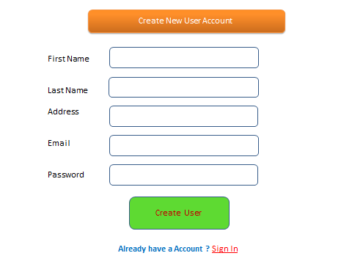

Figure 1.Create New User Account

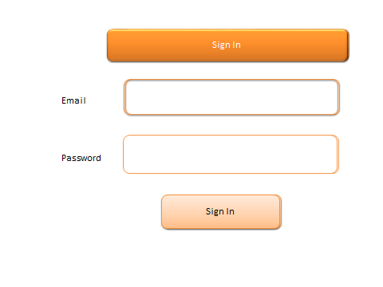

*Figure2. Login Page for All user*

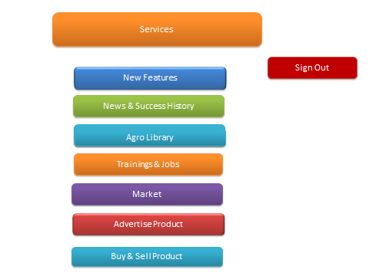

Figure 3. Agro Biz Services Homepage

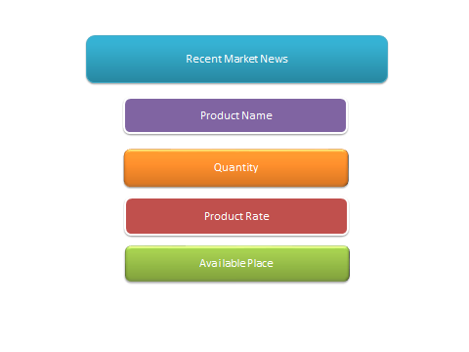

*Figure 4. Agro Market News and Updates*

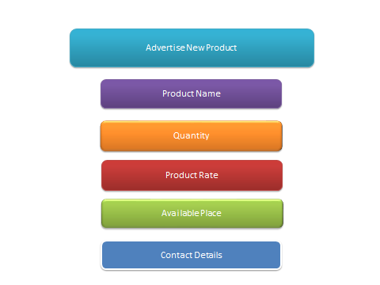

Figure 5. Advertise Agro Product

’

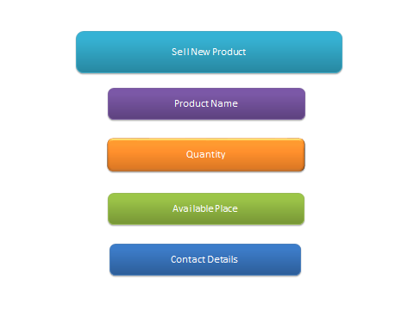

Figure 6. Sell Product

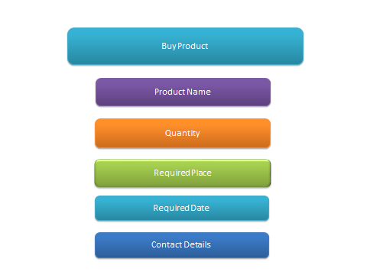

Figure 7. Buy Product

### 3.1.2 Hardware Interfaces

No specific hardware is required for the system. The program can be executed on any android phone which supports android OS.

### 3.1.3 Software Interfaces

This requires an android version of 5.0 or above.

### 3.3.4 Communications Interface

Communication between the different devices takes place via the internet.

## 3.2 Functional Requirements

### 3.2.1 Create user credentials

|  |  |
| --- | --- |
| Introduction | Create user credential to login to the system. |
| Inputs | First Name, Last Name, Address Email and Password. |
| Processing | Create the user credentials by storing the input values in the database on clicking the ‘Create User’ button. |
| Outputs | Redirects to Dashboard and with a message ‘User created successfully.’ |
| Error Handling | If any input parameters are missing, then shows error messages on the same page. |

### 3.2.2 Post Query, Sell/Advertise product

|  |  |
| --- | --- |
| Introduction | Create user to login to the system. |
| Inputs | First Name, Last Name, Address, Phone No, Email and Password. |
| Processing | Create connection with agricultural exports, customers and farmers |
| Outputs | Get reply and sell product |
| Error Handling | If any input parameters are missing then shows error messages on the same page. |

### 3.2.3 Agricultural product whole-sellers and retailers

|  |  |
| --- | --- |
| Introduction | Create connection with farmers and other customers |
| Inputs | First Name, Last Name, Address, Phone No, Email and Password |
| Processing | Connect with farmers and customers |
| Outputs | Redirects to Admin’s Dashboard and with a message ‘User created successfully.’ |
| Error Handling | If any input parameters are missing or the admin authentication failed, then shows error messages on the login page. |

### 3.2.4 Ask questions to Agricultural Exports

|  |  |
| --- | --- |
| Introduction | User can ask questions |
| Inputs | Question, Additional Information. |
| Processing | Create the new question by storing it in the database on clicking the “Post Question” button. |
| Outputs | Display reply of queries |
| Error Handling | If any input parameters are missing then shows error messages on the same page. |

### 3.2.5 Agricultural exports to reply the queries

|  |  |
| --- | --- |
| Introduction | Agricultural exports can respond to queries posted by users |
| Inputs | Queries |
| Processing | Get the queries and send reply. |
| Outputs | Redirects to Dashboard and with a replied answer. |
| Error Handling | If any input parameters are missing then shows error messages on the same page. |

### 3.2.6 Agricultural exports post information

|  |  |
| --- | --- |
| Introduction | Agricultural export can post their information for the users to view |
| Inputs | Information |
| Processing | Place the agricultural news, books and technology developed |
| Outputs | Display agricultural news |
| Error Handling | If any input parameters are missing then shows error messages on the same page. |

### 3.3.7 Agricultural product sellers

### 

|  |  |
| --- | --- |
| Introduction | Agricultural and animal product producers can add items with details. |
| Inputs | Product name, Quantity, Product rate, required place and contact details |
| Processing | Advertise product with details |
| Outputs | Display product with details |
| Error Handling | If any input parameters are missing then shows error messages on the same page. |

### 3.3.8 Customers can search for new product

|  |  |
| --- | --- |
| Introduction | Sales- person and consumers can search for items in the database. |
| Inputs | Item name |
| Processing | Search for the item in the database |
| Outputs | Display product with details |
| Error Handling | If any input parameters are missing, then shows error messages on the same page. |

### 3.3.9 Consumers can buy agricultural product

|  |  |
| --- | --- |
| Introduction | Consumer can buy product which are for sale. |
| Inputs | Agricultural product |
| Processing | Search the database for the product |
| Outputs | Redirects to the page with search results |
| Error Handling | If any input parameters are missing or no such item found, then shows error messages on the same page. |

## 3.3 Use Cases

### 3.3.1 Create user Credentials

|  |  |  |  |
| --- | --- | --- | --- |
| Use Case ID: | UC -1 | | |
| Use Case Name: | USER CONFIGURATION | | |
| Created By: | RAJU SHRESTHA | Last Updated By: | Raju Shrestha |
| Date Created: | 23/06/2017 | Date Last Updated: | 23/06/2017 |

|  |  |
| --- | --- |
| Actors: | ADMIN |
| Description: | CREATE USER CREDENTAILS TO LOGIN TO THE SYSTEM |
| Preconditions: | AGRO BIZ app downloaded and opened on android phone. |
| Post-conditions: | User logins to the application and changes made are updated in the database. |
| Normal Course: | 1. Sees a welcome message  2. Add new features and post market updates  3. Logout the system |
| Alternative Courses: | Sees an error message based on password mismatch or non-existence of the user |
| Exceptions: |  |
| Includes: |  |
| Priority: | HIGH |
| Frequency of Use: | HIGH |
| Business Rules | BR1, BR5 |
| Special Requirements: | * 24/7 access   Supported on Android mobile |
| Assumptions: | Supported by only on Android operating system |
| Notes and Issues: |  |
| Use Case Graphics | Login  Configure Users Credentials and update new features    Actor – Admin  Logout |

### 3.3.2 Post Query, Sell/Advertise product

|  |  |  |  |
| --- | --- | --- | --- |
| Use Case ID: | UC – 2 | | |
| Use Case Name: | AGRO PRODUCERS (FARMER) | | |
| Created By: | RAJU SHRESTHA | Last Updated By: | Raju Shrestha |
| Date Created: | 23/06/2017 | Date Last Updated: | 23/06/2017 |

|  |  |
| --- | --- |
| Actors: | AGRO PRODUCERS (FARMER) |
| Description: | POST A QUERY, ADVERTISE/SELL PRODUCT. |
| Preconditions: | AGRO BIZ app downloaded and opened on android phone |
| Post-conditions: | User logins to the mobile application and changes made are updated. |
| Normal Course: | 1. Sees a welcome message 2. Post their queries and see market updates 3. Perform a search 4. Advertise their product if they want to sell them 5. Logout of the system |
| Alternative Courses: | Sees an error message based on password mismatch or non-existence of the user |
| Exceptions: | None |
| Priority: | High |
| Frequency of Use: | HIGH |
| Business Rules | BR2, BR4 |
| Special Requirements: | * 24/7 access * Supported on android phone. |
| Assumptions: | Admins and agricultural experts will be able to respond to his queries and costumers can contact. |
| Notes and Issues: |  |
| Use Case Graphic | Login  Post a query sees market updates  Advertise/Sell their product  Actor – Agro Producers  (Farmer)  Check if there any costumers  Logout  Search for customers |

### 3.3.3 Agricultural product whole-sellers and retailers

|  |  |  |  |
| --- | --- | --- | --- |
| Use Case ID: | UC – 3 | | |
| Use Case Name: | RESPOND TO QUERIES AND  ADVERTISE THEIR PRODUCT | | |
| Created By: | RAJU SHRESTHA | Last Updated By: | Raju Shrestha |
| Date Created: | 23/10/2017 | Date Last Updated: | 23/10/2017 |

|  |  |
| --- | --- |
| Actors: | WHOLE-SELLERS AND RETAILERS |
| Description: | THEY RESPOND TO A QUERY MADE BY A CUSTOMERS (CONSUMERS) AND ADVERTISE THEIR PRODUCT AND FACILITIES. |
| Preconditions: | AGRO BIZ app downloaded and opened on android phone |
| Post-conditions: | User logins to the Android application changes made are updated. |
| Normal Course: | 1. Sees a welcome message. 2. Respond to queries 3. Advertise their products 4. Logout of the system |
| Alternative Courses: | Sees an error message based on password mismatch or non-existence of the user |
| Exceptions: | None |
| Priority: | High |
| Frequency of Use: | HIGH |
| Business Rules | BR3, BR4 |
| Special Requirements: | * 24/7 access * Supported by Android phone |
| Assumptions: | Supported on only Android operating system |
| Notes and Issues: |  |
| Use Case Graphic | Login  Respond to a query  Advertise their products  Actor – Whole-Sellers  And Retailers  Logout |

### 3.3.4 Agricultural product buyers/consumers

|  |  |  |  |
| --- | --- | --- | --- |
| Use Case ID: | UC – 4 | | |
| Use Case Name: | BUY PRODUCTS | | |
| Created By: | RAJU SHRESTHA | Last Updated By: | Raju Shrestha |
| Date Created: | 23/10/2017 | Date Last Updated: | 23/10/2017 |

|  |  |
| --- | --- |
| Actors: | Consumers, Retailers and Whole-sellers of agricultural products |
| Description: | POST THEIR NEED WITH PRODUCT DETAILS |
| Preconditions: | AGRO BIZ app downloaded and opened on android phone |
| Post-conditions: | User logins to the Android application and changes made are updated in the database. |
| Normal Course: | 1. Sees a welcome message 2. Sets requirements 3. Order product with details 4. Logout of the system |
| Alternative Courses: | Sees an error message based on password mismatch or non-existence of the user |
| Exceptions: | None |
| Priority: | High |
| Frequency of Use: | HIGH |
| Business Rules | BR4 |
| Special Requirements: | * 24/7 access * Supported by Android phone. |
| Assumptions: | Supported on only Android operating system |
| Notes and Issues: |  |
| Use Case Graphic | Order products  Login  Logout  Actor–Agro product consumers |

### 3.3.5 Agricultural Experts

|  |  |  |  |
| --- | --- | --- | --- |
| Use Case ID: | UC – 3 | | |
| Use Case Name: | POST CONVENTIONAL TECHNIQUES AND METHODS TO PRODUCE QUALITY PRODUCT | | |
| Created By: | RAJU SHRESTHA | Last Updated By: | Raju Shrestha |
| Date Created: | 23/10/2017 | Date Last Updated: | 23/10/2017 |

|  |  |
| --- | --- |
| Actors: | EXPERTS |
| Description: | ADD NEW INFROMATION |
| Preconditions: | AGRO BIZ app downloaded and opened on android phone |
| Post-conditions: | User logins to the android application changes made are updated. |
| Normal Course: | 1. Sees a welcome message. 2. Respond to queries 3. Add new information 4. Logout of the system |
| Alternative Courses: | Sees an error message based on password mismatch or non-existence of the user |
| Exceptions: | None |
| Priority: | High |
| Frequency of Use: | HIGH |
| Business Rules | BR3, BR4 |
| Special Requirements: | * 24/7 access * Supported on Android phone. |
| Assumptions: | Supported by only on Android phone. |
| Notes and Issues: |  |
| Use Case Graphic | Login  Add new information  Logout  Actor – Agricultural Experts |

*For the business rules refer to the BRD.

## 3.4 Classes / Objects

### 3.4.1 Users

|  |
| --- |
| **Attributes** |
| User ID |
| First_name |
| Last_name |
| Address |
| Email |
| Password |

|  |
| --- |
| **Functions** |
| Full_name |
| Authenticate |

### 3.4.2 Agro product sellers

|  |
| --- |
| **Attributes** |
| Market name |
| Address |

|  |
| --- |
| **Functions** |
| Find by market name and address |

### 3.4.3 Agro Producers (Farmer)

|  |
| --- |
| **Attributes** |
| Product ID |
| Product type |
| Product name |

|  |
| --- |
| **Functions** |
| Find by product ID and name |

## 3.5 Non-Functional Requirements

### 3.5.1 Performance

The system should support at concurrent users. Many users can use the app to access the information within the system at the same time. Display time changes must be done quickly and efficiently.

### 3.5.2 Reliability

The reliability of this application depends on the reliability of the separate components present within this application. However, the system should never crash other than there is an operating system error. Also, the system should respond in smooth way, even if there is error in network. The system should respond well even for big set of data and large number of users.

### 3.5.3 Availability

The apps will be available on Google play store and the users can download it at any time.

### 3.5.4 Security

The system is secured by the means that all the password of the users will be saved encrypted in the database. It ensures the privacy of the users. The system will be protected against online hacking such as SQL injection attacks.

### 3.5.5 Maintainability

The database of this system in maintained by using MySQL and sever is the Apache server. In case of failure of this system through any means, both the database and server can be re-initialized.

### 3.5.6 Portability

This application is an android operating system based but it could not be compatible with other system. The technologies used to build this application are system dependent. The application can therefore do not run on any other operating system.

## 3.6 Design Constraints

The design constraints are:

* The application layout will be produced using HTML/CSS/JS.
* The application will be coded in JAVA.
* The database will be MySQL database.
* The source code will follow coding conventions of JAVA.

## 3.7 Logical Database requirements

All the data will be saved in the MySQL database. The information includes user details, item details and the transaction details. The database can only be accessed by the administrator using the database login credentials. RDBMS approach is used to build the database design.

# 4. Analysis Models

## 4.1 Sequence Diagram

### 4.1.1 Sequence diagram for Admins

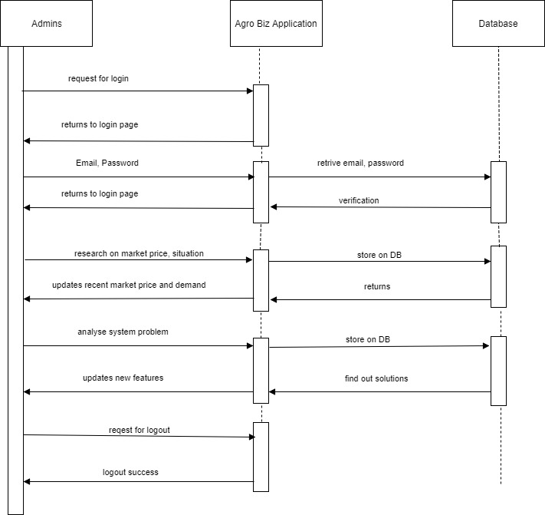

*Figure 8. Sequence diagram for Admins*

### 4.1.2 Sequence diagram for Agro Product Producer (Farmer)

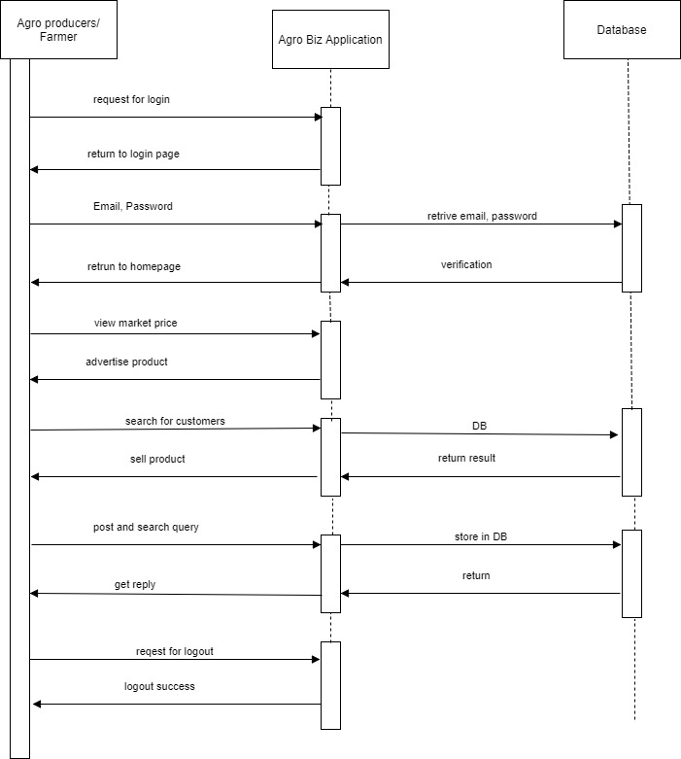

*Figure 9. Sequence diagram for Agro Producer (Farmer)*

### 4.1.3 Sequence diagram Agro product sellers (whole-sellers/retailers)

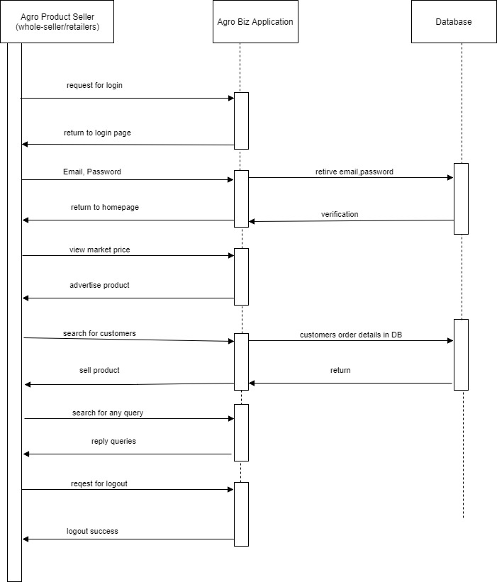

*Figure 10. Sequence diagram Agro product seller*

### 4.1.4 Sequence diagram for Agricultural exports

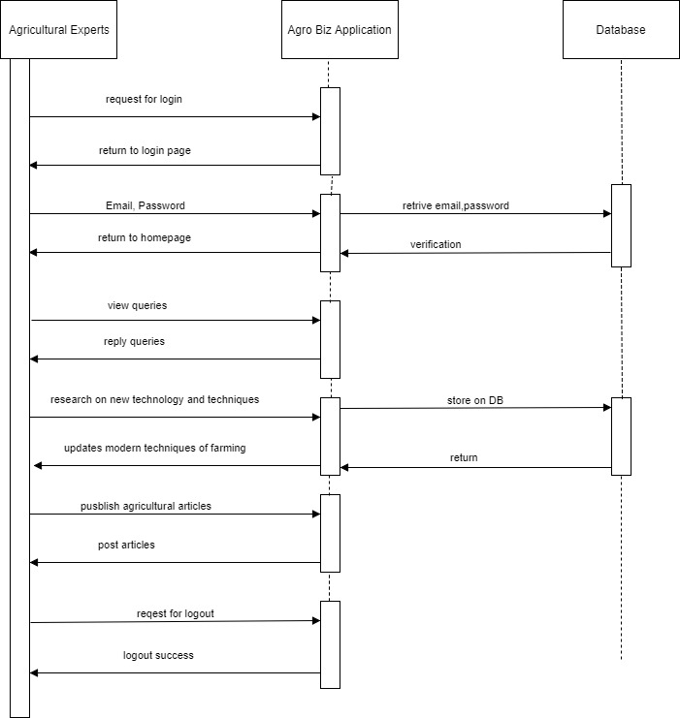

*Figure 11. Sequence diagram for Agricultural Experts*

## 4.2 Data Flow Diagrams (DFD)

### 4.2.1 Context diagram

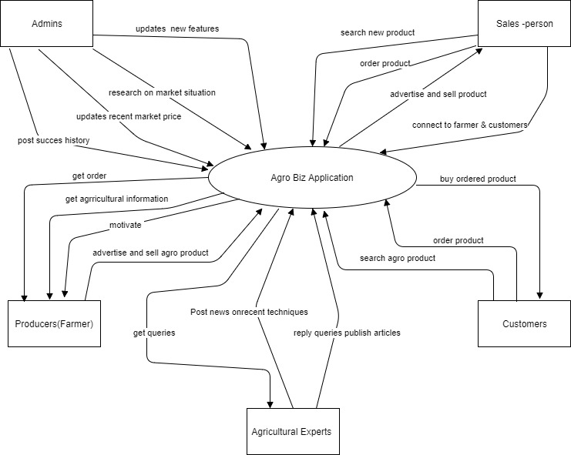

Figure 12. Context diagram

### 4.2.2 Diagram for queries request/response

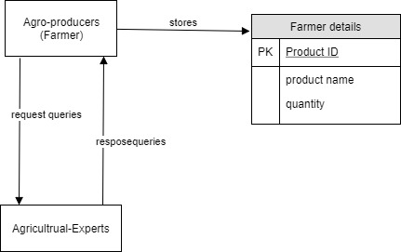

Figure 13. Diagram for queries request/response

### 

### 4.2.3 Diagram for buying/selling product

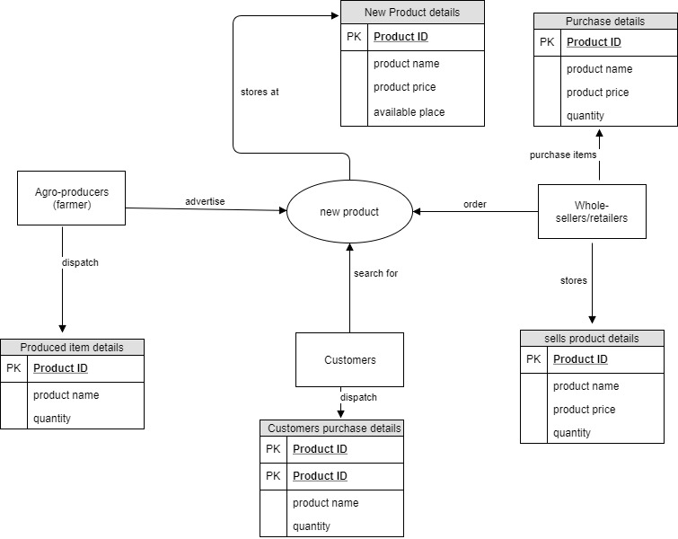

Figure 14. Diagram for buying/selling module)

## 4.3 State Diagrams

### 4.3.1 State diagram for admin

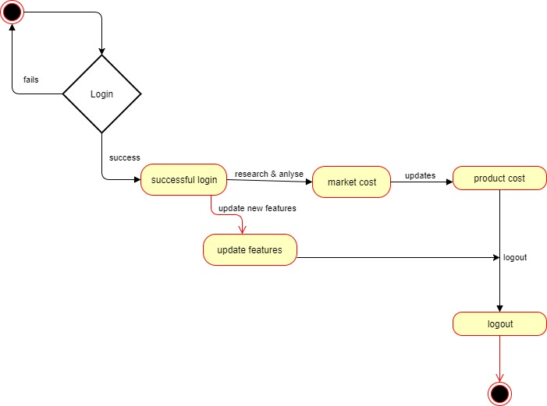

Figure.15 State diagram for admin

### 4.3.2 State diagram for Agro-Producers (Farmer)

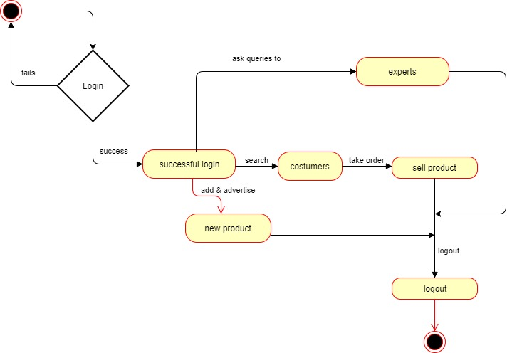

### 

*Figure 16. State diagram for Agro-Producers (Farmer)*

### 4.3.3 State diagram for Agricultural Experts

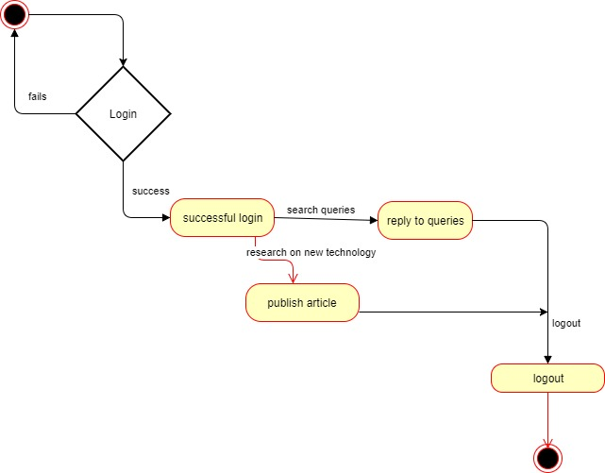

Figure 17. State diagram for Agricultural Experts

### 4.3.4 State diagram for Agro-Product Sellers (whole-sellers/retailers)

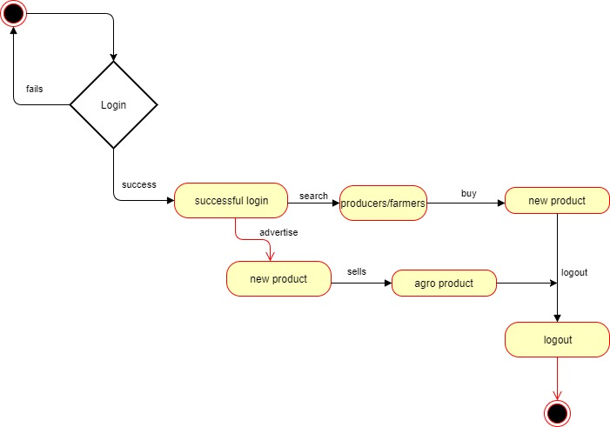

Figure 18. State diagram for Agro-Product Sellers (whole-sellers/retailers)

### 4.3.5 State diagram for costumers/consumers

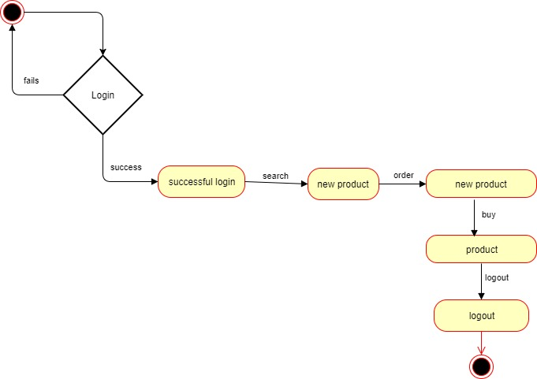

Figure.19 State diagram for costumers/consumers

# 5. Change Management Process

Changes will be brought in the SRS will be made if any extra feature is to be added or certain features need to be reduced or combined with added features. Changes in project scope or requirement will be made according to changes brought in features and user characteristics. The updated SRS will be submitted to the instructor. Upon the review and approval of instructor changes will be made in the system.

# A. Appendices

## A.1 Business Requirement Document

* Business Requirement Document, Agro Biz by Raju Shrestha, Deerwalk Institute Of Technology